ESTIMATION OF PARAMETERS AND ERROR PREDICTION FOR INSTRUMENT TRANSFORMER USING MACHINE LEARNING
Pranit Menkar ^{*1}, Pranjal Nankar^{*2}
^{*1}Student, Department of Information Technology, K. K. Wagh Institute of Engineering Education and Research, Nashik, Maharashtra, India
^{*2}Student, Department of Information Technology, K. K. Wagh Institute of Engineering Education and Research, Nashik, Maharashtra, India

ABSTRACT
Transformers are employed widely for varying purposes. In the making of different kinds of transformers, various different parameters are present which need to be precisely calculated before the actual manufacturing of the product. From input parameters to materials required for the manufacturing process of the product, every value needs to be calculated accurately to avoid errors and wastage of raw materials. Even today these values are being calculated manually, which leads to errors. So, the automation of the manual process of computation is necessary to get the desired requirements of the final product. Based on the purpose and the inputs provided by user the application does the automated computation and displays the results and 3D model of the transformer that provides a better view, also the phase and ratio errors are predicted before testing of transformer using Machine Learning model and the design sheet is printed.
Keywords: Instrument transformers, Current transformer, Potential Transformer, 3D model, Error Prediction, Machine Learning, Design Sheet
- INTRODUCTION
To calculate the parameters of instrument transformer, no such application exists to compute those. Thus the calculations are done manually by individuals which leads to errors sometimes. So to overcome these errors and automate the calculation process of parameters we are developing an application for it.
- METHODOLOGY
The present invention is for automating the parameter computation of instrument transformer, displaying the 3D model and error prediction of it. To use the application,
Stage 1: Registration Process:
Firstly, the user can login if he /she already has an account or signup by creating a new account into the system using username and password. Then, system will validate the credentials.
Stage 2: Selection of type of transformer:
After that, user is provided with option to choose the type of transformer whether Current Transformer or Potential Transformer.
Stage 3: Enter the required parameters and Display of results
Then later on User has to provide inputs to the application, system based on those inputs will calculate the desired outputs and display the design sheet. If the parameters or inputs provided by the user are already existing in the database, then the system will retrieve those from it and then display to user.
Stage 4: Displaying 3D model and error prediction results:
The system will also create a 3D model for the specific Transformer based on parameters provided by the user. It will also predict the errors in the model before the testing phase of the job. The admin can add or modify parameters as per his/her desire. Finally, the user can logout of the system.

- WORKING MODULES
- Main Page - The fig 3.1 depicts the Main page of the website named TransformerGO. It provides two functionalities to either Register or Login. If the user is new to the website, he/she needs to first register themselves by providing the necessary details. If the user is already existing, he/she can directly Login.
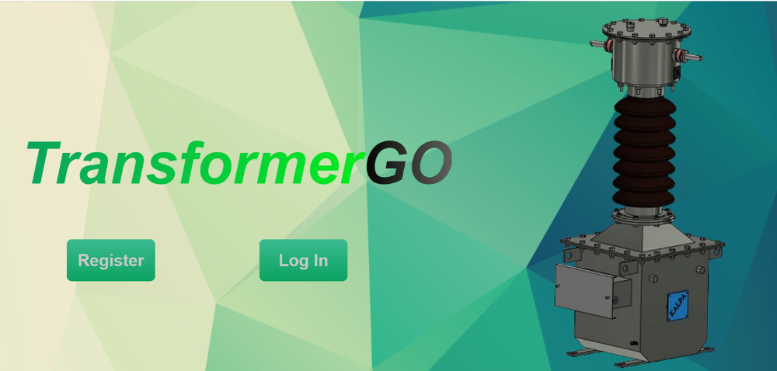
Figure 3.1: Main Page
- Registration Page - The fig 3.2 depicts the Registration Page of the website. If the user is new to the website, he/she needs to first register themselves by providing the required information like Username, Email and Password to be set. The password needs to be reentered in order to confirm it.
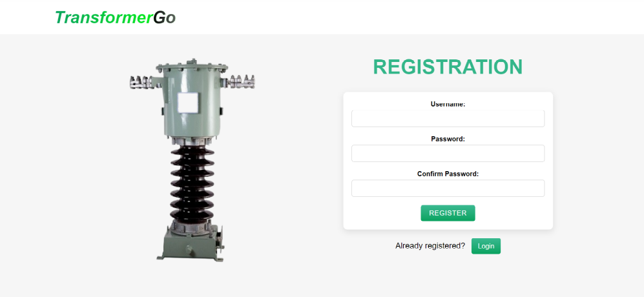
Figure 3.2: Registration Page
- Login Page - The fig 3.3 depicts the Login Page of the website. The already registered user can get an access to the website by just providing the login details which are Username and Password set earlier. 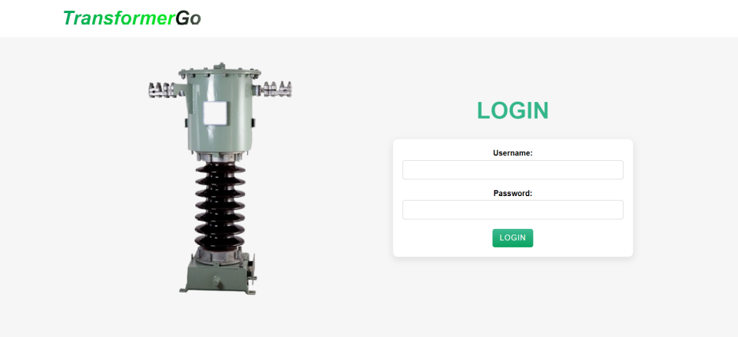
Figure 3.2: Login Page
- Home Page - The fig 3.4 depicts the Home Page for the website. It provides the user to select any one of the two transformer either Current Transformer or Potential Transformer to do the further computation whichever is required as per need. User also may Sign-out from the current page

Figure 3.4: Home Page
- Inputs for Current Transformer - The fig 3.5 depicts the Inputs for Current Transformer Page where a user when he/she selects the current transformer to do the further processing. It allows user to provide their required requirements like the inputs for Current Transformer are Burden, Voltage Rating, Class, Current Voltage Ratio and Short Time Current.
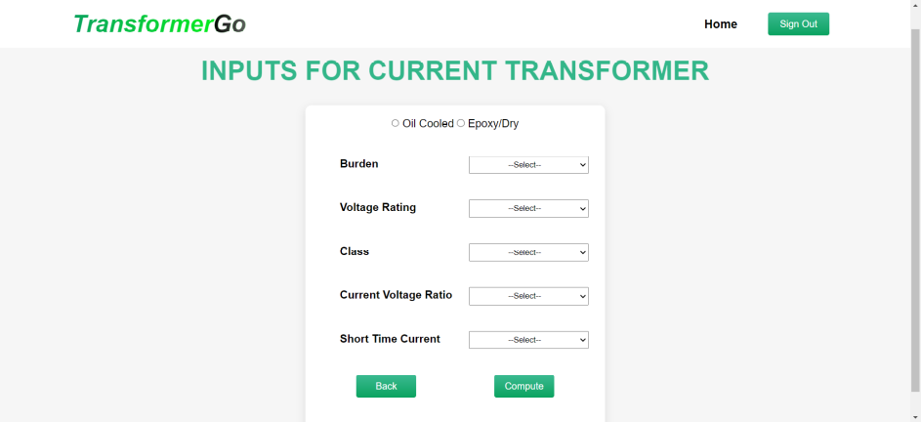
Figure 3.5: Inputs for Current Transformer Page
- Inputs for Potential Transformer - The fig 3.6 depicts the Inputs for Potential Transformer Page where a user when he/she selects the Potential transformer to do the further processing. It allows user to provide their required requirements like the inputs for Current Transformer are Burden, Voltage Rating, Class and Short Time Current.
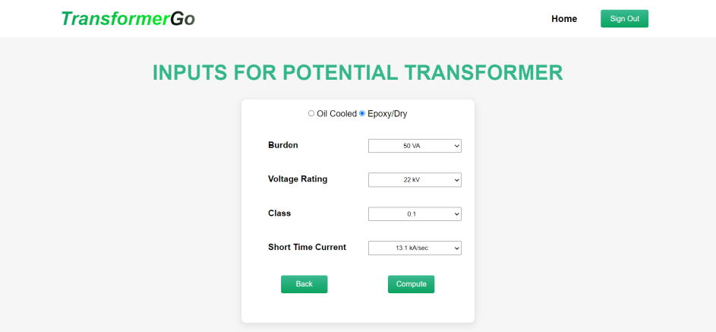
Figure 3.6: Inputs for Potential Transformer Page
- RESULTS AND DISCUSSION
- Current Transformer –
The fig 4.1,4.2 depicts the output page for Current Transformer based on the inputs provided by the user according to their requirements and the 3D model of the same is also being displayed. The 3D model can be zoomed, rotated along the axis to have a better view of the transformer. It also displays the dimensions along with it.

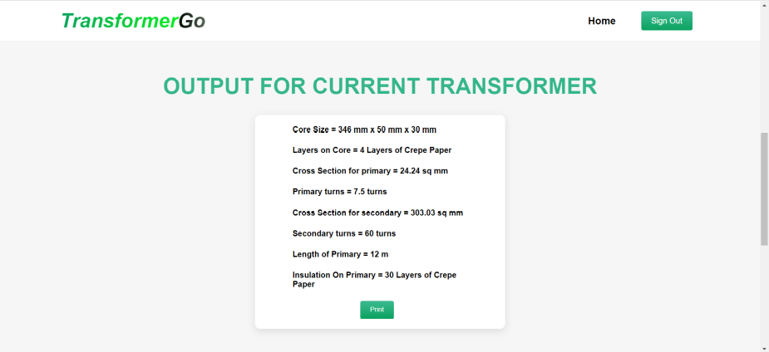
Figure 4.1: Output Page for Current Transformer
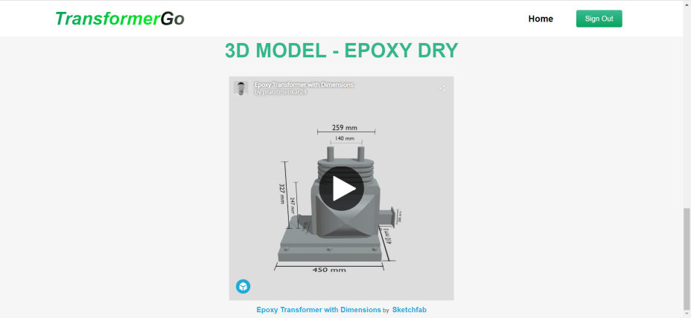
Figure 4.2: Output Page for Current Transformer
- Potential Transformer –
The fig 4.3,4.4 depicts the output page for Potential Transformer based on the inputs provided by the user according to their requirements and the 3D model of the same is also being displayed. The 3D model can be zoomed, rotated along the axis to have a better view of the transformer. It also displays the dimensions along with it.
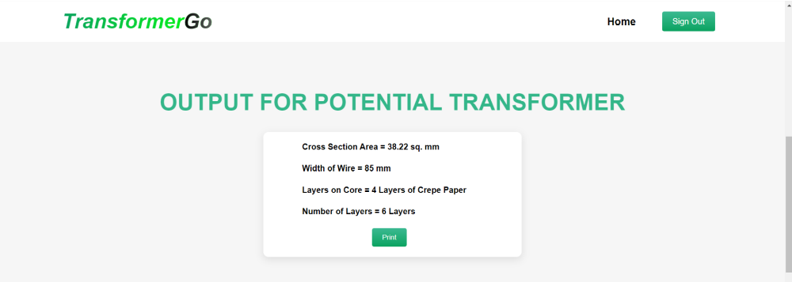
Figure 4.3: Output Page for Potential Transformer
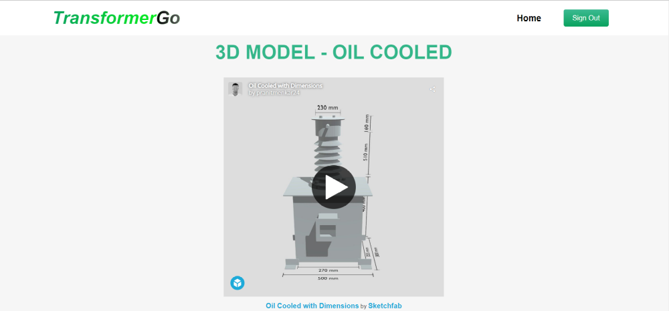
Figure 4.4: Output Page for Current Transformer
- Error Prediction –
The fig 4.5 depicts the output page for the prediction of errors that is the phase error and ratio error. These errors are predicted in prior that is before the preparation of the job. The data set is divided into training and testing values. The model is trained using the training values and then uses those values to predict the next required values.
- The model used is Densenet Layers-Dense Net was specially developed to improve accuracy caused by the vanishing gradient in high-level neural networks due to the long distance betweeninputandoutputlayerstheinformationvanishesbeforereachingitsdestination.
- The error function used is Binary Cross Entropy-Binary cross entropy compares each of the predicted probabilities to actual class output which can be either 0 or 1. It then calculates the score that penalizes the probabilities based on the distance from the expected value. That means how close or far from the actual value.
- The activation function used is Sigmoid function-A sigmoid function is a mathematical function with a characteristic” S” – shaped curve or sigmoid curve. It transforms any value in the domain to a number between 0 and 1.
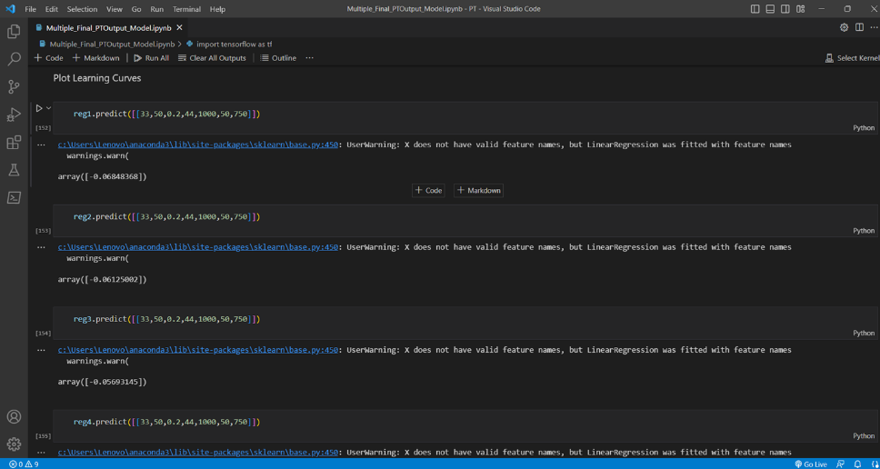
Figure 4.5: Output Page for Error Prediction

- Design Sheet –
After the automatic computation of the parameters of instrument transformer based on the inputs provided by the user, the website provides a functionality to print the design sheet for that transformer. It includes the input parameters as well as the outputs computed in a well presented printable format. The fig 4.6 depicts a sample design sheet.
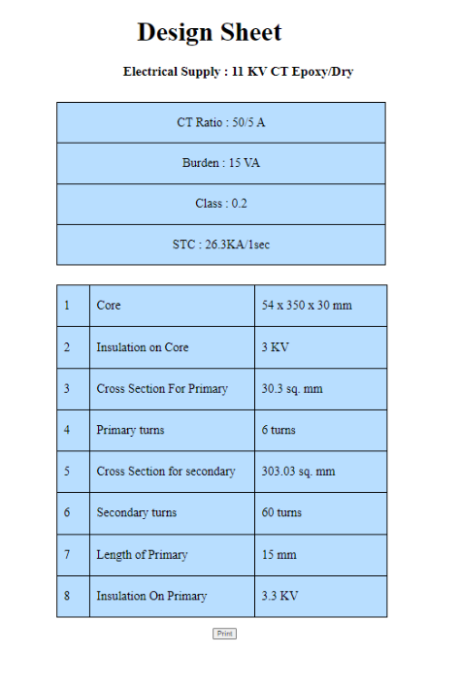
Figure 4.6: Design Sheet
- CONCLUSION
To prevent errors and the loss of raw materials, it is necessary to compute every value, from input parameters to the materials needed for the product’s manufacturing process. Even now, there are inaccuracies because these quantities are still calculated manually. Therefore, automation of the human computing process is required to meet the desired criteria for the finished result. The 3D model, the design, and the specifications of the transformer will be displayed.3D model of the Transformer created enables a better view of it from all the 3 dimensions. Prediction of errors before testing helps to know the accuracy of the job.
ACKNOWLEDGEMENTS
We feel great pleasure in expressing our deepest sense of gratitude and sincere thanks to our Prof. Nitin Dhamale guide for their valuable guidance during the Project work, without which it would have been very difficult task. We have no words to express our sincere thanks for valuable guidance, extreme assistance and cooperation extended to all the Staff Members of our Department. We would like to convey our heartfelt gratitude to Prof. Rupali M. Bora for her tremendous support and assistance and giving us the opportunity to work on a sponsor project. This acknowledgement would be incomplete without expressing our special thanks to Dr. Preeti D Bhamre, Head of the Department (Information Technology) for her support during the work. We would also like to extend our heartfelt gratitude to our Principal, Dr. K.N. Nandurkar who provided a lot of valuable support, mostly being behind the veils of college bureaucracy. Last but not least we would like to thanks all the Teaching, Non- Teaching staff members of our department, our parents and colleagues those who helped us directly or indirectly for completing of this Project successfully. We wish to extend our special thanks to Advent Engineers and especially to Mrs. Prem Lata Mishra and Miss Arya Mishra who have provided a lot of technical support and proper guidance throughout.
- REFERENCES
- http://www.prolificindia.com/transformer-test-pro-ttp-software-for-transformer-testing.html
- https://www.electrical4u.com/instrument-transformers/
- https://www.electricaldeck.com/2021/01/errors-characteristics-reducing-errors-in-current transformer.html: :text=The
- https://studyelectrical.com/2018/09/current-transformer-ct-construction-working-operating- principle-advantages-uses.html
- https://www.tutorialspoint.com/what-is-potential-transformer-p-t-and-how-it-works

